Sending a Qualtrics Survey in Coursera

Please follow these steps exactly to ensure that we capture Coursera IDs in our surveys. However, please let instructors and other people using the data know that we can never be 100% sure that Coursera IDs are collected because sometimes changes made to the coding in the Coursera platform cause things to function differently than expected. For that reason, we encourage people to also collect email addresses as back-up identifiers.

- In your course, click on Content -> Section Manager

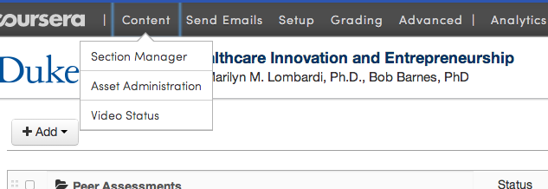

- Click on Add -> Announcement

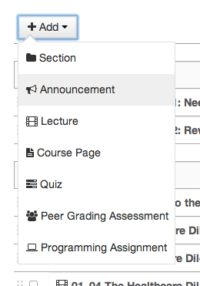

- Type the title you want the announcement to have – usually something like “[Course name] Post-Course Survey”. Then click the pencil to edit your new announcement.

- Type your announcement in the message box. You should place the survey link in a hyperlink by highlighting the word(s) you want to lead to the survey and then clicking on the “link” button.

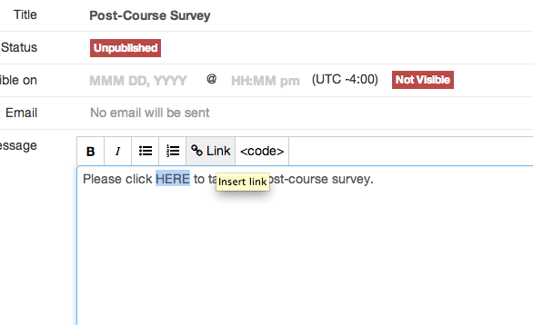

- In the box that pops up, paste in the survey link copied exactly from the email you received. It should end with the string %SESSION_USER_ID%. Then click “Create”.

- You should also type the following, “If you are unable to click on the link above, please copy and paste the following in to your web browser to complete the survey:”

- After that sentence, hit Enter and paste the full survey link in to the email. IMPORTANT – DO NOT SEND THE ANNOUNCEMENT YET. It is very likely that the final % mark in the link you just pasted in is NOT hyperlinked (see screen shot below)

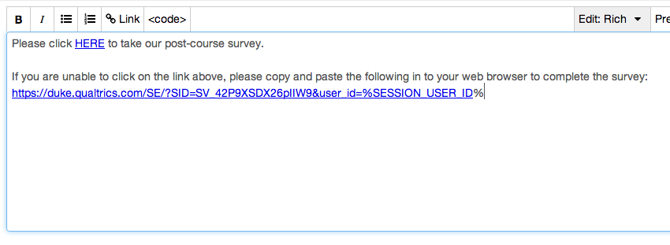

- Highlight the entire link that you just pasted in and click again on the Link button. Paste the link here in full and click Create. You should now see that the full link is blue and hyperlinked.

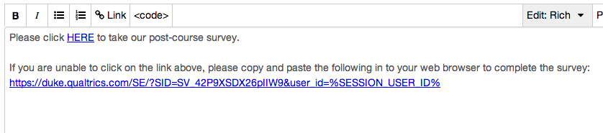

- If for any reason you make an error during this final step and the link looks different in any way from the above screen shot, you must erase all the text in the announcement and start over. Once Coursera attaches a link to something, it is virtually impossible to change it.

- Once the announcement is ready, enter a date and time for the “Visible on” fields, click on the right side to turn emails on, and click the “Publish” link

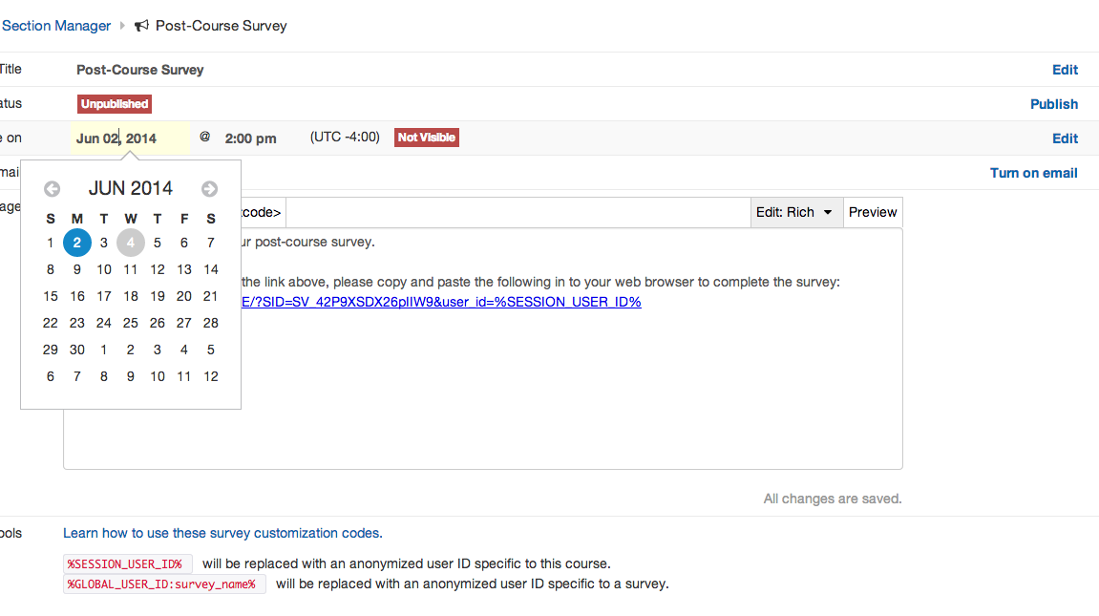
Email
Publish
Date and time

